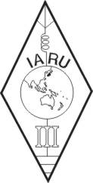 | INTERNATIONAL AMATEUR RADIO UNION  REGION 3  SIXTEENTH REGIONAL CONFERENCE | 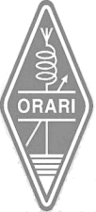
12 – 16 October 2015 Bali, Indonesia

Document No. 15/XVI/029
Agenda Item: 12.7

KARL AWARD PROGRAM
Below is a list of KARL award program revised in July, 2015.
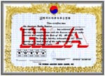
  a) Categories
  Class K : requires 5 HL QSLs
  Class O : requires 10 HL QSLs
  Class R : requires 20 HL QSLs
  Class E : Requires 30 HL QSLs
  Class A : Requires 50 HL QSLs
  **Stickers will be issued when 50 additional QSLs are confirmed.
  b) Application
  - An application form is in the 'Official Form' menu and shoud be signed by two amateur radio operators.
  - Fee is 8 IRCs or $5US by Paypal to HL0HQ@hanmail.net (award or sticker application).
  c) Other Requirements
  - QSOs only made after February 1959 shall be counted.
  - QSOs with HL9(US militay in Korea) shall not be counted.
  - Separate applications by band and mode are possible.
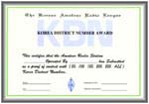
  a) Categories
  KDN 50: Requires 50 QSLs with different KDNs
  KDN 100: Requires 100 QSLs with different KDNs
  KDN 150: Requires 150 QSLs with different KDNs
  KDN 200: Requires 200 QSLs with different KDNs
  KDN 250: Requires 250 QSLs with different KDNs
  All KDN: Approved any numbers of different KDN QSLs as of the date of application.
  b) Application
  - An application form is in the 'Official Form' menu and shoud be signed by two amateur radio operators.
  - Fee is 8 IRCs or $5US by Paypal to HL0HQ@hanmail.net.
  c) Other Requirements
  - QSOs only made after February 1959 shall be counted.
  - QSOs with HL9(US militay in Korea) shall not be counted.
  - Separate applications by band and mode are possible.
  - Up to date KDN list is in the 'Official Form' menu.
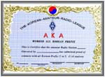
  a) Requires 6 QSLs of 6 different call areas (1/2/3/4/5/0 area).
  b) Application is the same as HLA award.
  - An application form is in the 'Official Form' menu and shoud be signed by two amateur radio operators.
  - Fee is 8 IRCs or $5US by Paypal to HL0HQ@hanmail.net.
  c) Other Requirements
  - QSOs only made after February 1959 shall be counted.
  - QSOs with HL9(US militay in Korea) shall not be counted.
  - Separate applications by band and mode are possible.
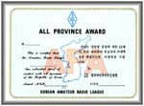
  a) Requires 16 QSLs including Seoul, six metropolitan cities and nine provinces.
  ** Six metropolitan cities are Busan, Daegu, Daejeon, Incheon, Gwangju, Ulsan
  ** Nine Provinces are Gyeonggi-do, Gangwon-do, Gyeongsangbuk-do, Gyeongsangnam-do, Chungcheongnam-do, Chungcheongbuk-do, Jeollabuk-do, Jeollanam-do, Jeju-do
  b) Application
  - An application form is in the 'Official Form' menu and shoud be signed by two amateur radio operators.
  - Fee is 8 IRCs or $5US by Paypal to HL0HQ@hanmail.net.
  c) Other Requirements
  - QSOs only made after February 1959 shall be counted.
  - QSOs with HL9(US militay in Korea) shall not be counted.
  - Separate applications by band and mode are possible.
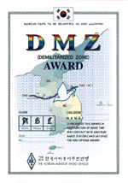
  a) Categories
  Class A: Requires 15 entities
  Class B: Requires 10 entities
  Class C: Requires 5 entities
  b) Requirements
  - QSOs only made with stations whose nations are in latitude of
  thirty-eight degrees north shall be counted.
  (prefixes: 9H/BY/CT/EA/EP/EY/EZ/HL/I/JA/P5/SV/TA/UJ/W/YA/YI)
  - QSOs only made after February 3rd 1959 shall be counted.
  - One HL QSL shall be included.
  c) Application
  - An application form is in the 'Official Form' menu and shoud be signed by two amateur radio operators.
  - Fee is 8 IRCs or $5US by Paypal to HL0HQ@hanmail.net.
  d) Others
  - This award will be issued until the unification of Korean Peninsular.

  a) Categories
  Class A
  Class B
  Class C
  b) Requirements
  - Class A : Requires 17 QSLs(local/foreign) to make a phrase of
  "KARL NEW MILLENNIUM" with the last letter of the suffix.
  They shall include six Continents and five HL areas
  (out of six areas : 1,2,3,4,5,0).
  - Class B : Requires 17 HL QSLs with different KDNs to make a
  phrase of "KARL NEW MILLENNIUM" with the last letter of the suffix.
  - Class C : Requires 17 QSLs(local/foreign) to make a phrase of
  "KARL NEW MILLENNIUM", regardless continents or HL areas.
  ** QSOs only made from January 2000 to December 31 2000 shall
  be counted
  ** Any specific band(bands) or mode(modes) is not required.
  ** QSOs with the same station on different bands or with different
  modes are valid, provided that the same QSL shall not be counted twice.
  c) Application
  - An application form is in the 'Official Form' menu and shoud be signed by two amateur radio operators.
  - Fee is 8 IRCs or $5US by Paypal to HL0HQ@hanmail.net.

